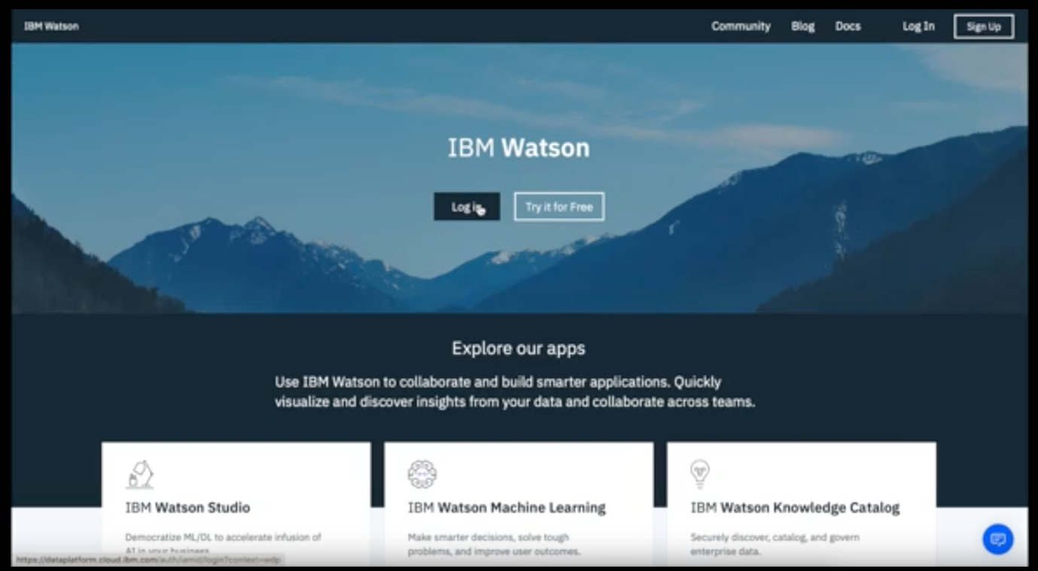

Visit <https://dataplatform.cloud.ibm.com> and check out the above landing page of IBM Watson data platform.

Make a sign up or use your existing IBM Cloud credentials to login (Provide existing user name and password) – Shown Above

On the top left corner select the  hamburger menu button and select “View All Catalogs”

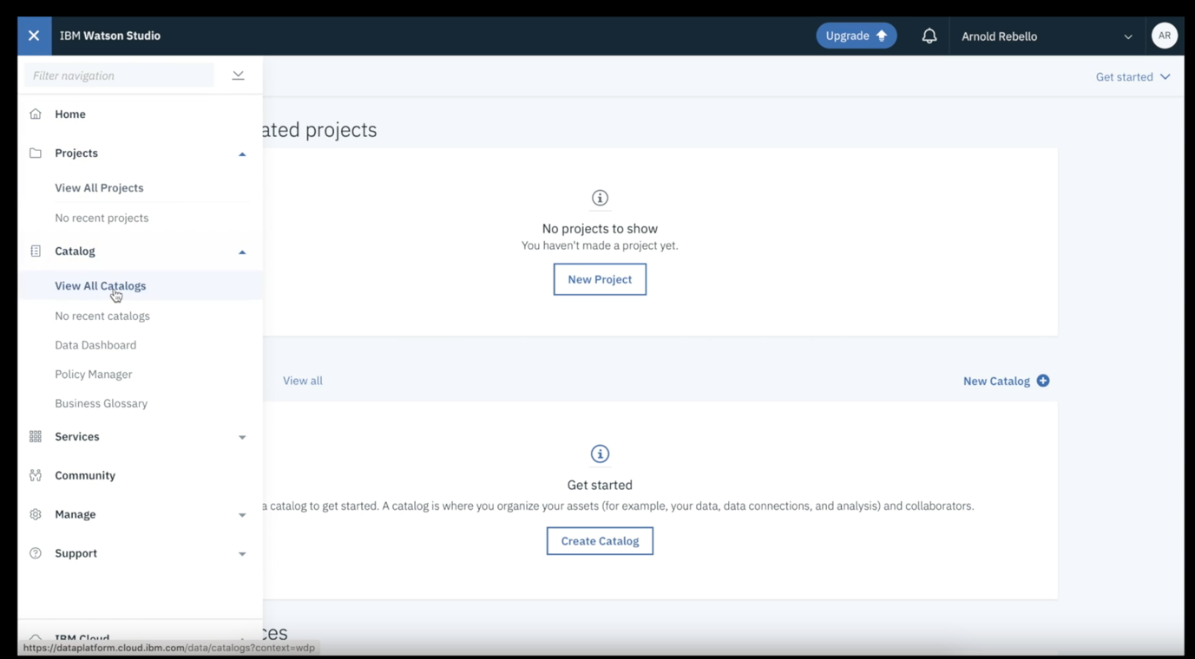

Click on Create Catalog

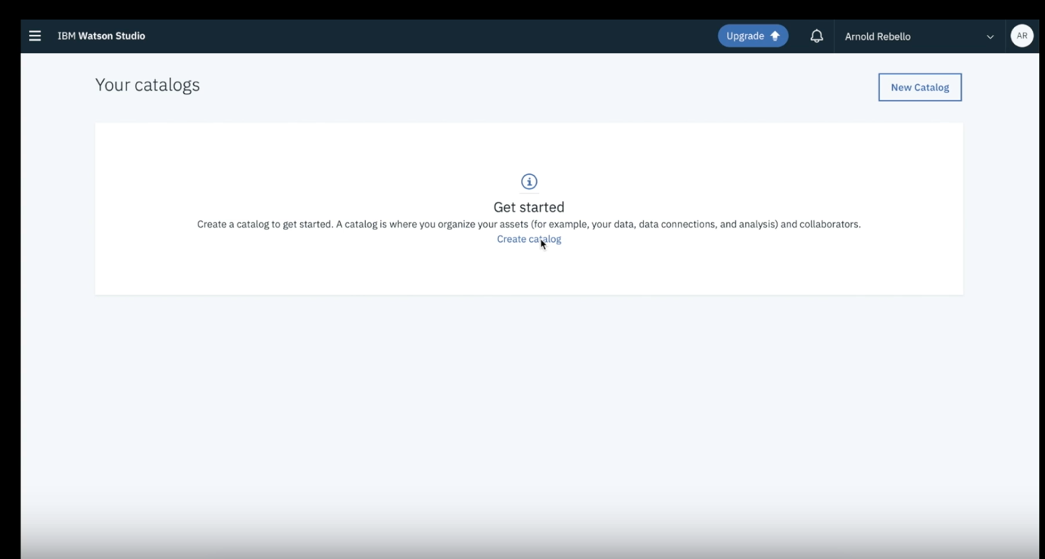

Provide a new name to your catalog and add some description and check on “Enforce data policies” as shown below.

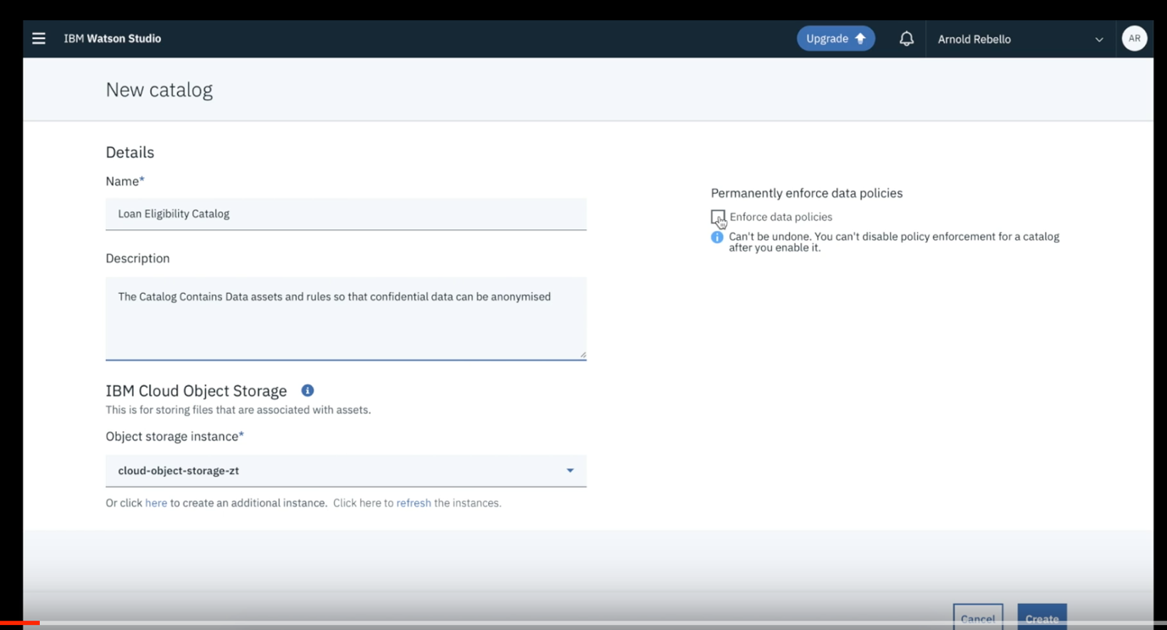

Click OK to enforce data policies and press create to initiate a catalog.

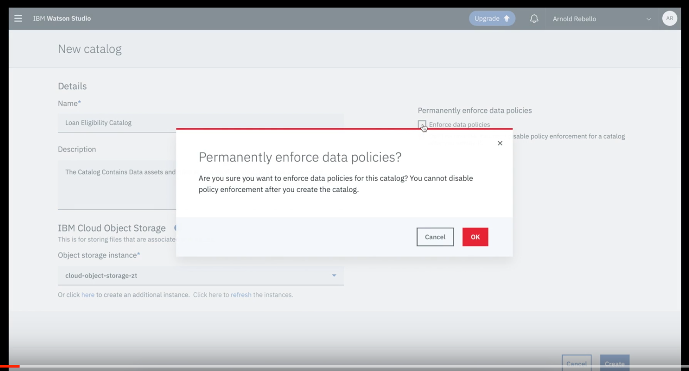

Now.. Since, we have created a catalog. We will add a dataset from the local system. Click on Add to Catalog >> Local files to upload a dataset shared with you separately (Train_indessa_new.csv in this Case). As shown in the steps below.

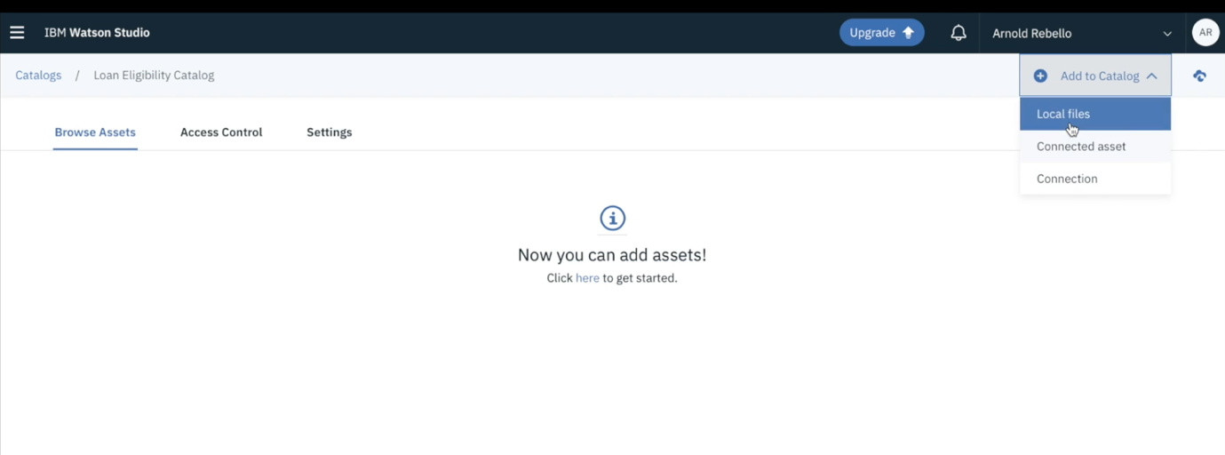

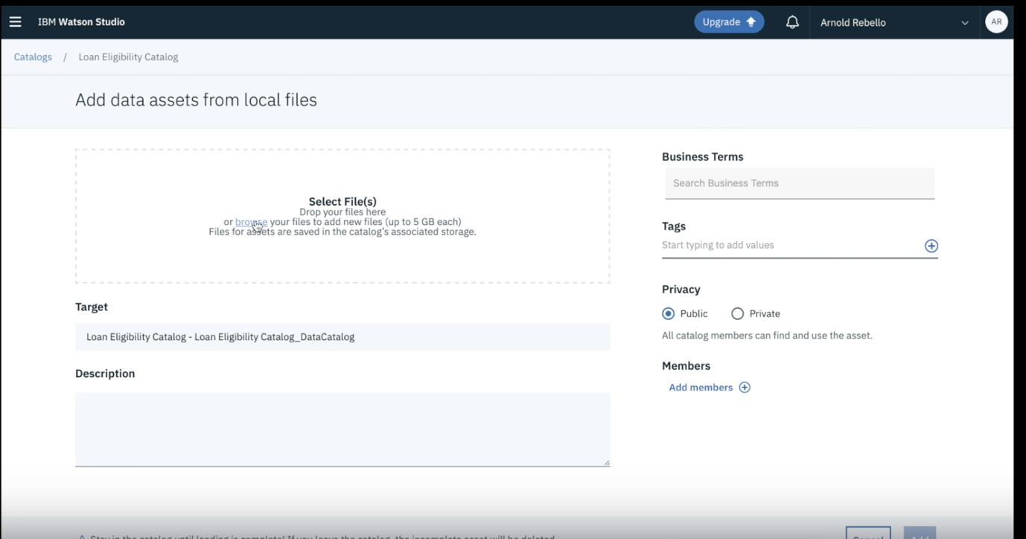

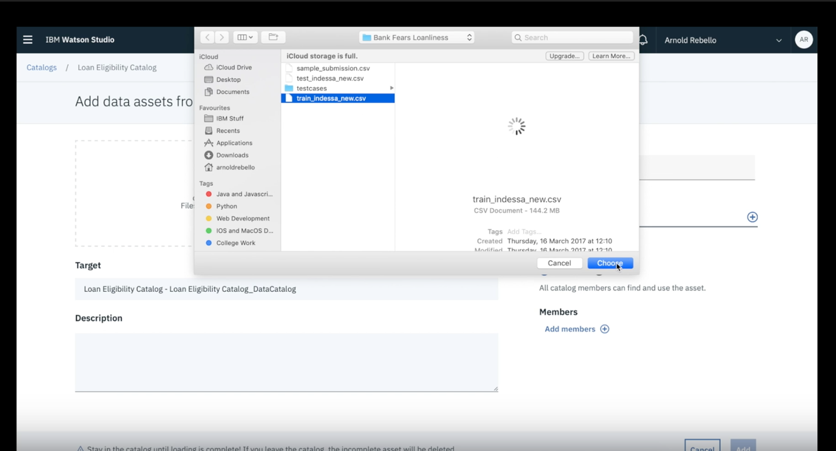

Once the data asset is uploaded. On the right hand side “Select” + sign and add data asset as a tag. Click add button on the right bottom.

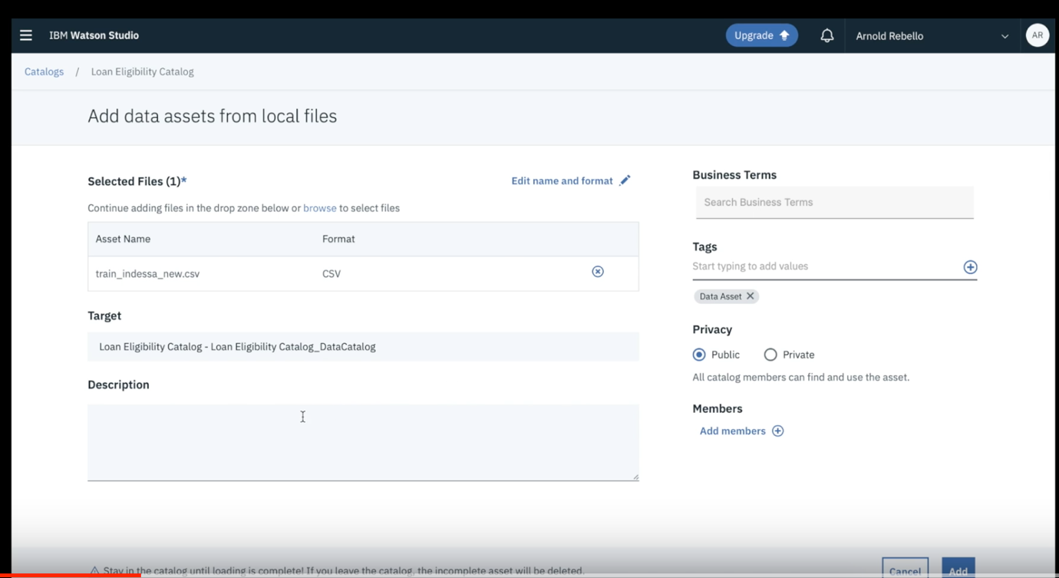

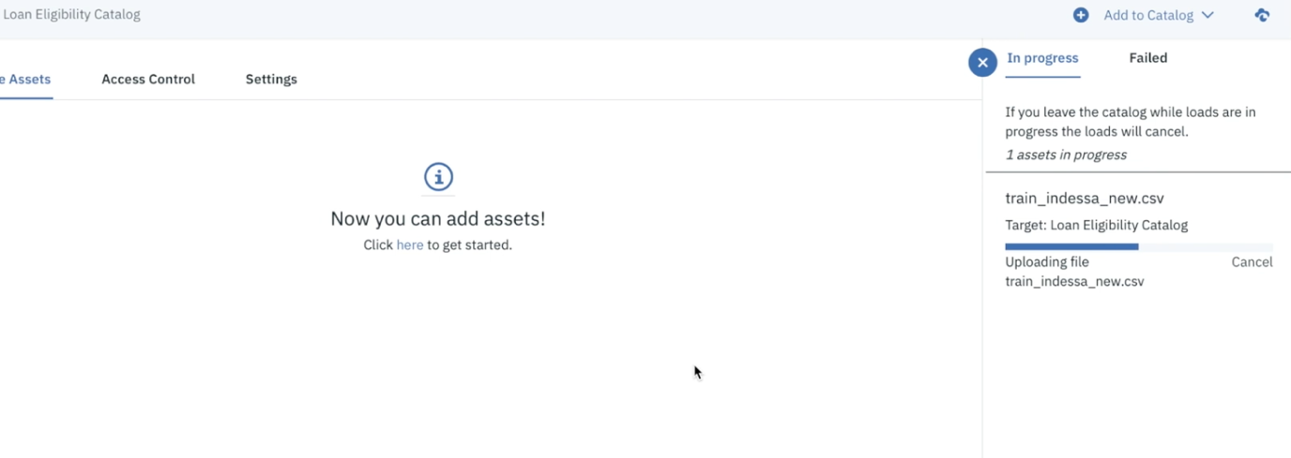

Click on the added data asset.

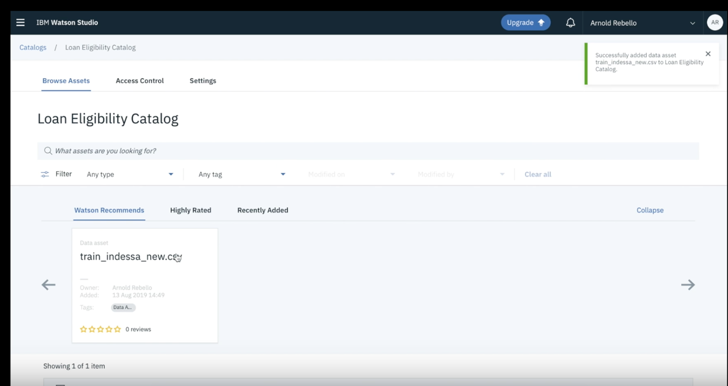

Add on Profile button as shown in the picture below. It will take some time to create the profile

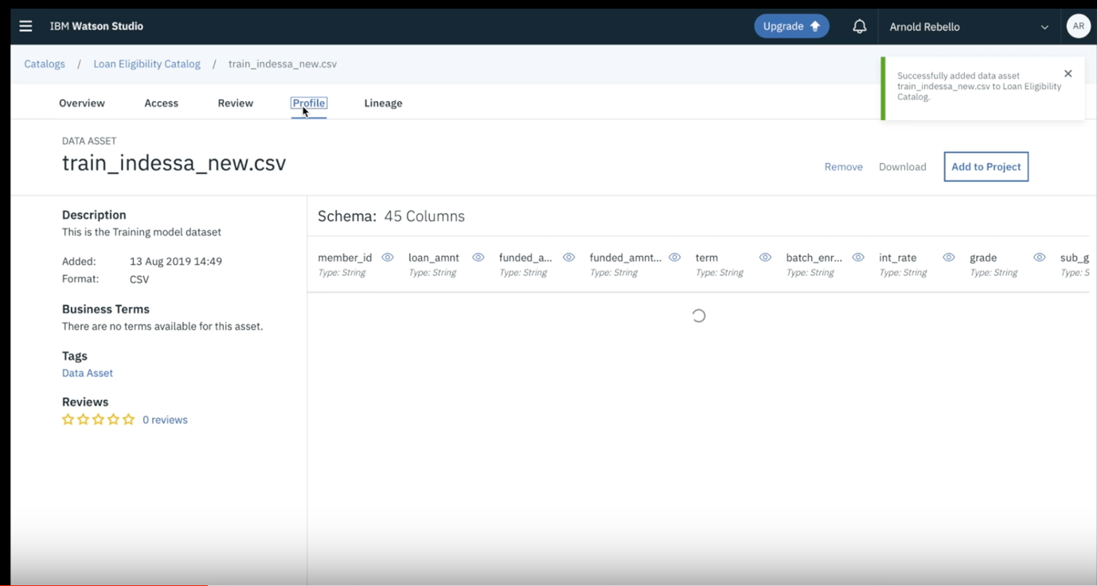

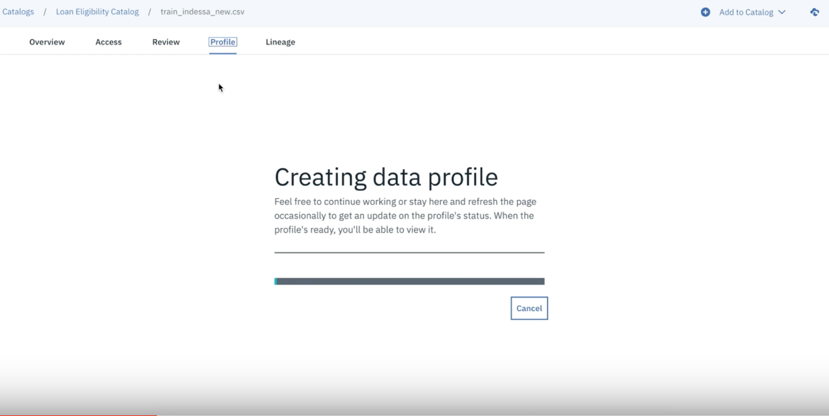

Once the data profiling is done, you should be able to see the below dashboard under the “Loan eligibility catalog” created earlier. Now, we are able to visualize the data and do the necessary changes in the data set like data type changes (Varchar/String/Text/Values etc.) and Update the profile by clicking on the update profile button as shown below.

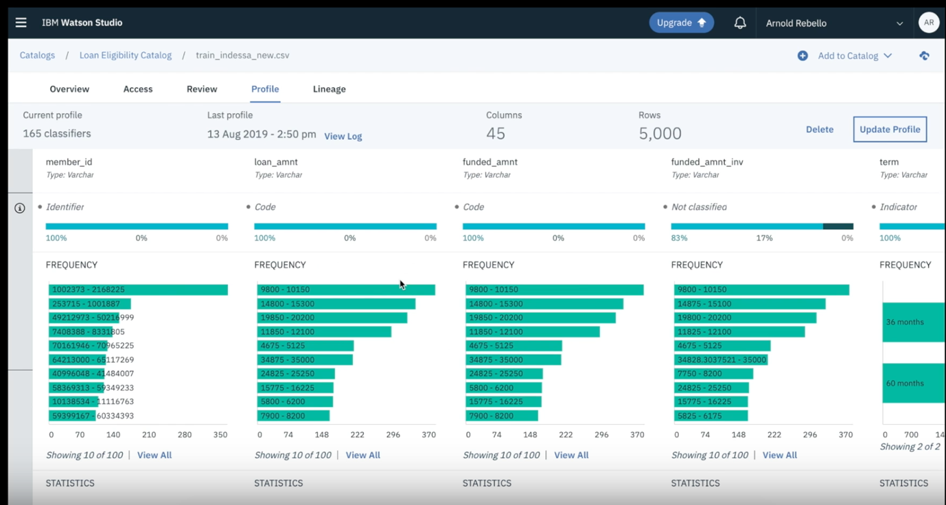

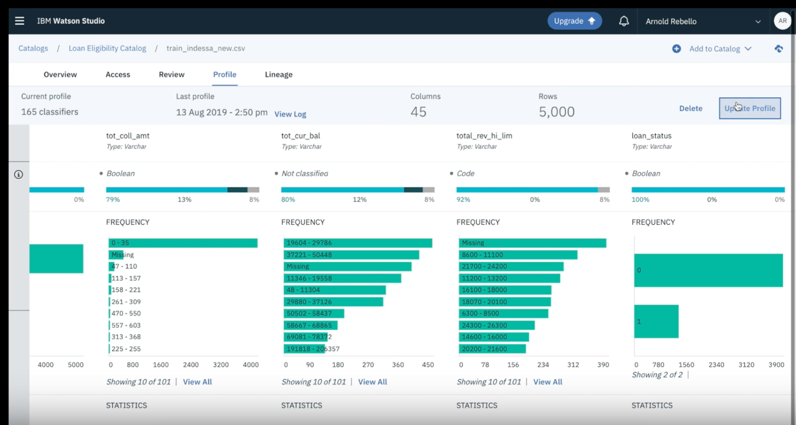

Next step is to apply some policy and rules in the data set and observe the real time changes on the dashboard.

Click on the hamburger menu button again on the top left corner of the screen and select “Policy manager” under the catalog drop down.

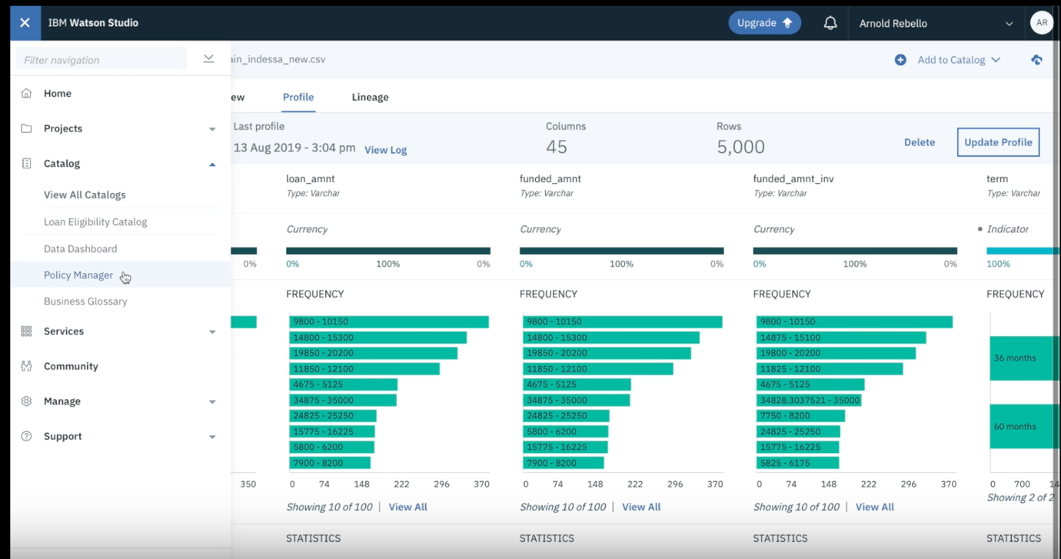

Click on add and select a new category

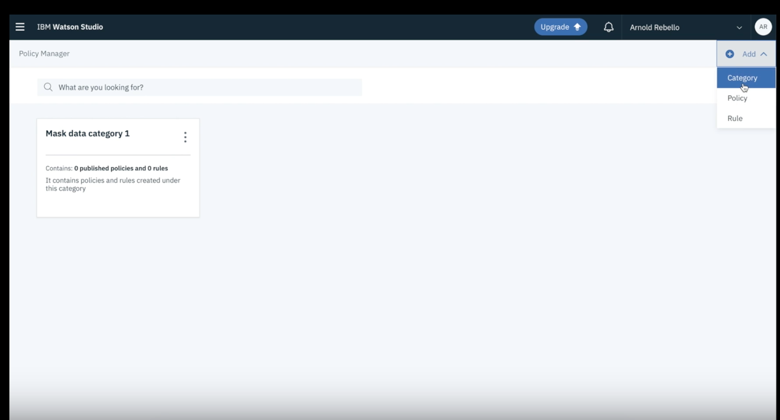

Give a name to your new category and description

.

Now in this section, we will create a policy to anonymise the confidential data points from the assets uploaded earlier. Follow the steps as shown below.

And click create.

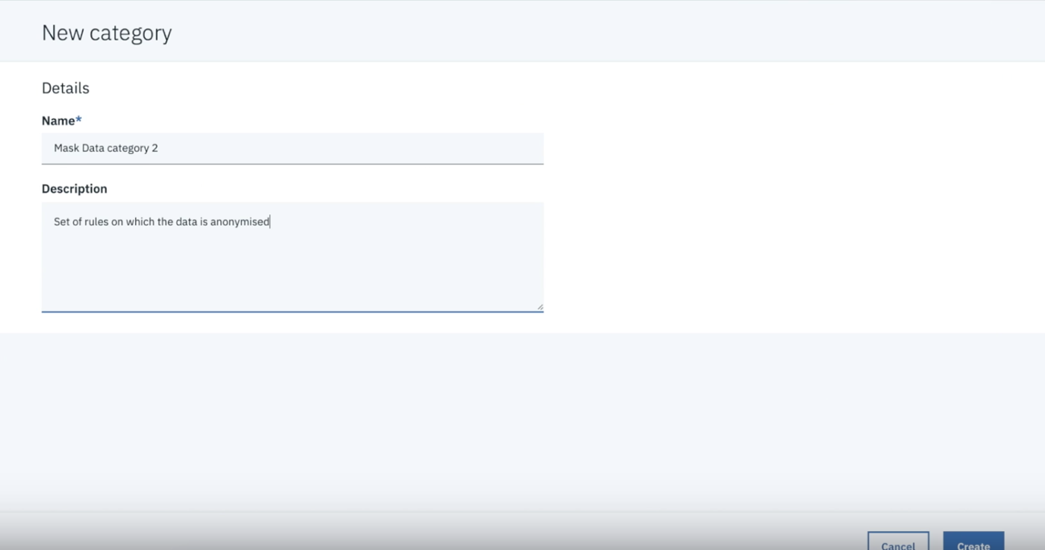

In the new category, Click add and select policy. Here, we’re creating a new policy .

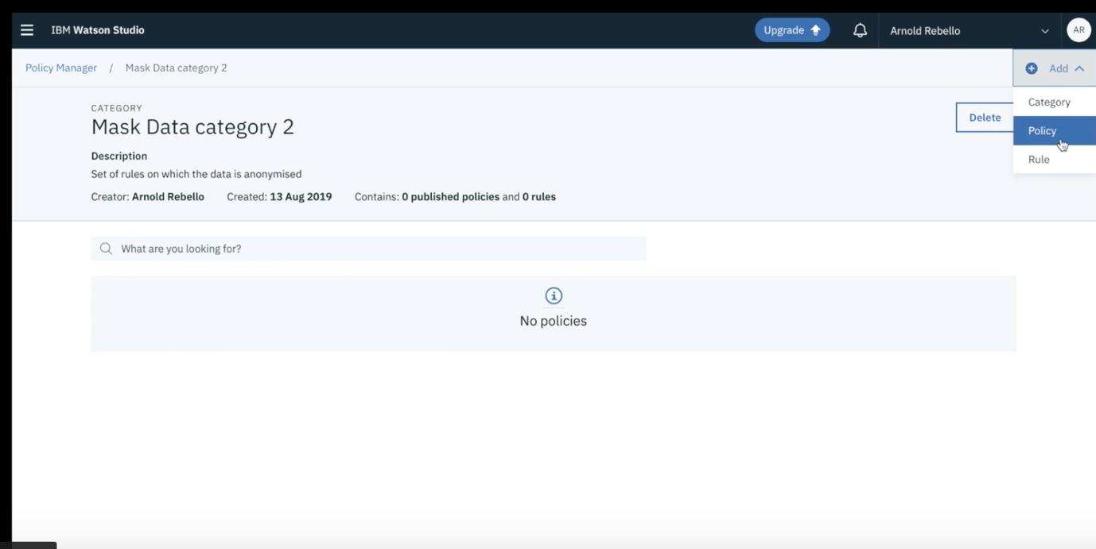

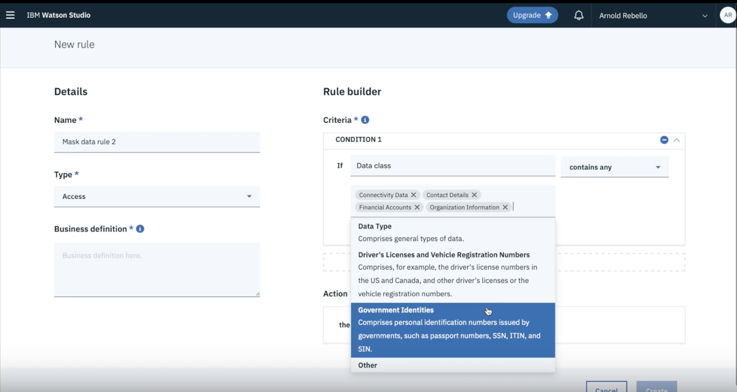

Now, we will add a new rule here by adding some conditions. As we mentioned before that we are creating a policy to anonymise a critical confidential data points from the data set.

Let’s create a rule in the rule builder as shown below.

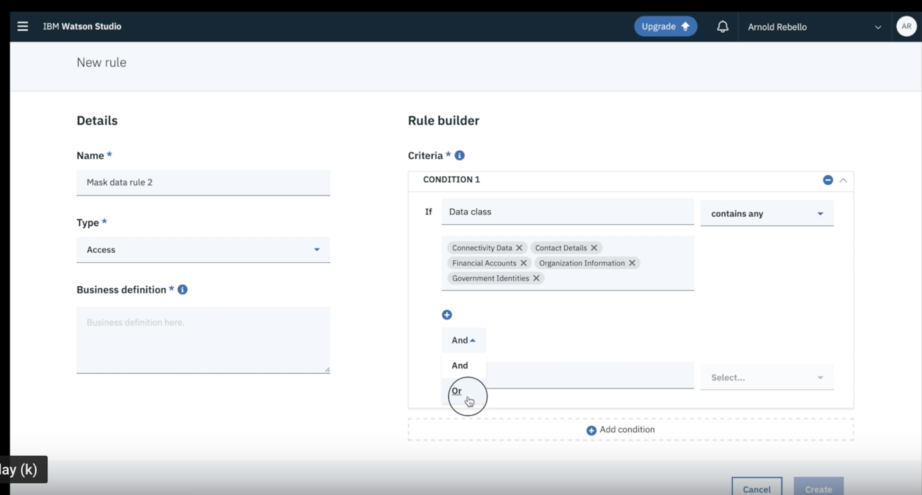

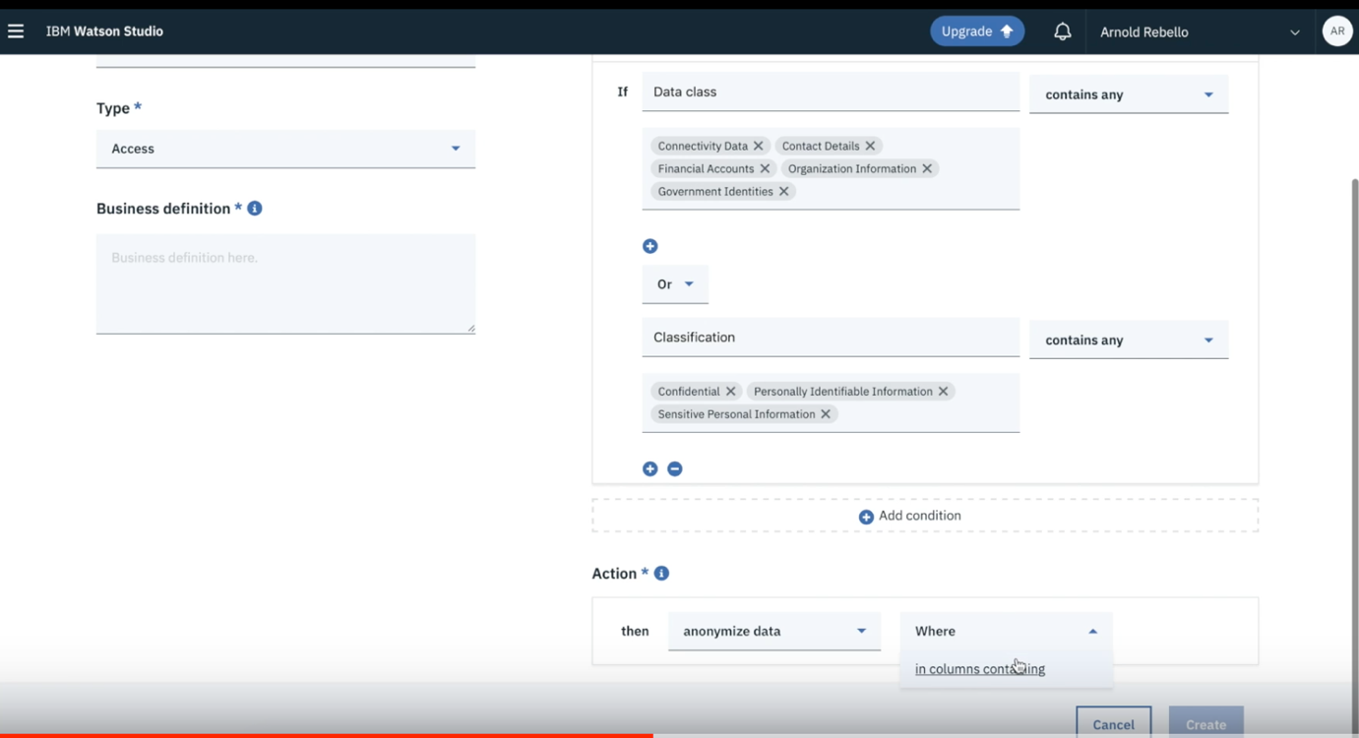

In this rule we will hide the confidential data and replace it with XXXX or with some random value (By Selecting how to anonymise data) Shown below.

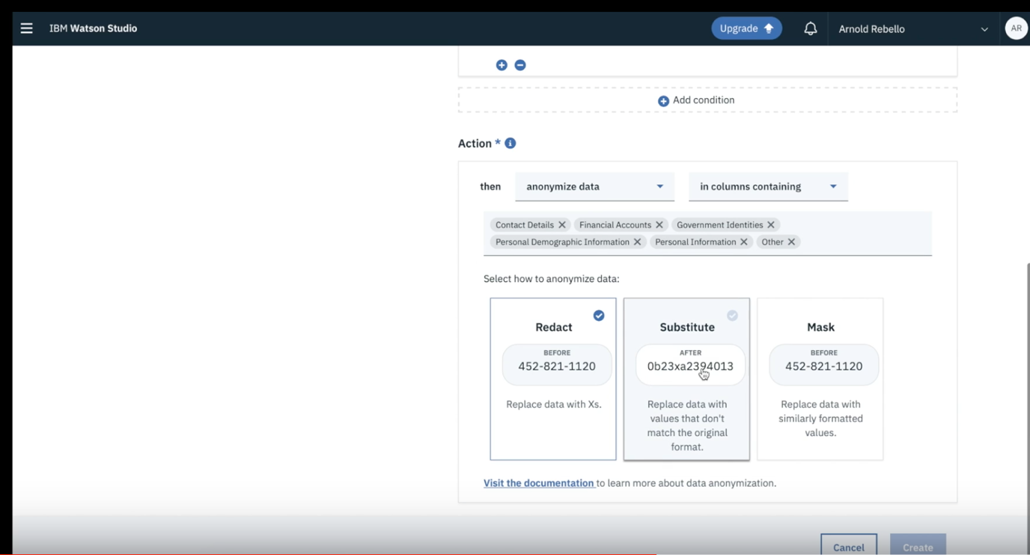

Add the business justification and click on create.

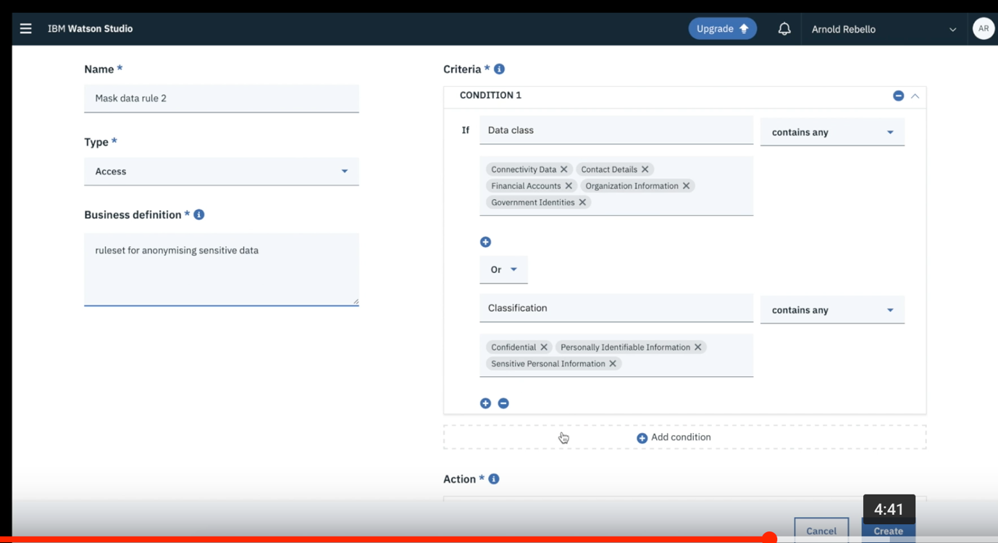

From the hamburger menu Select “View all projects”.

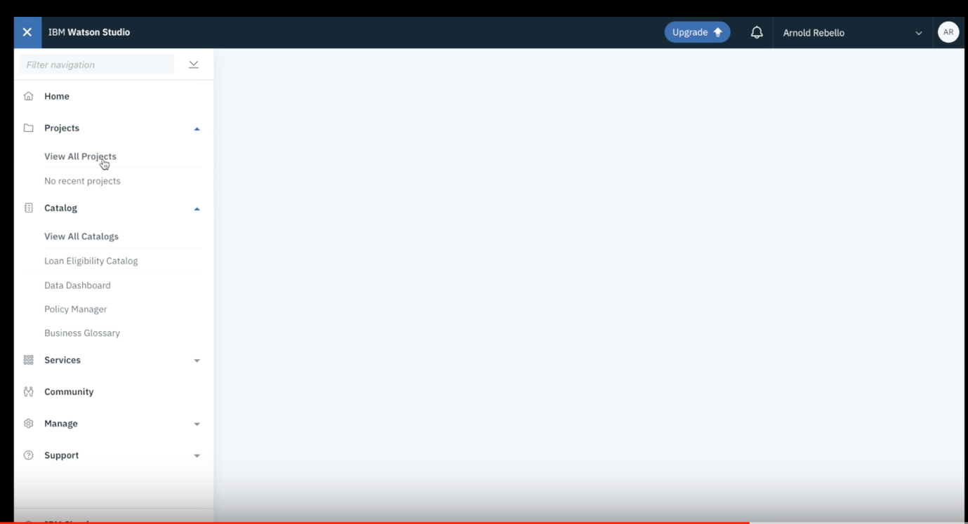

Click on “New Project”

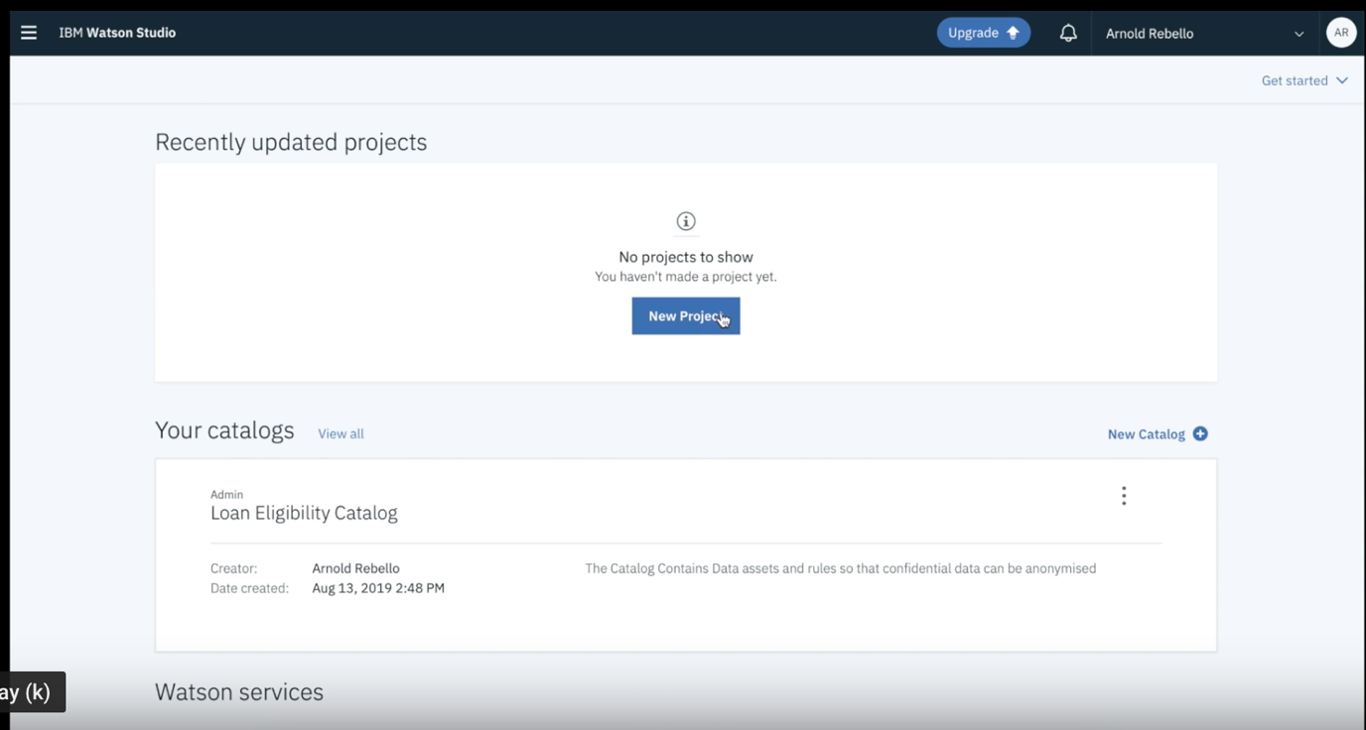

Select “ Create an empty project”.

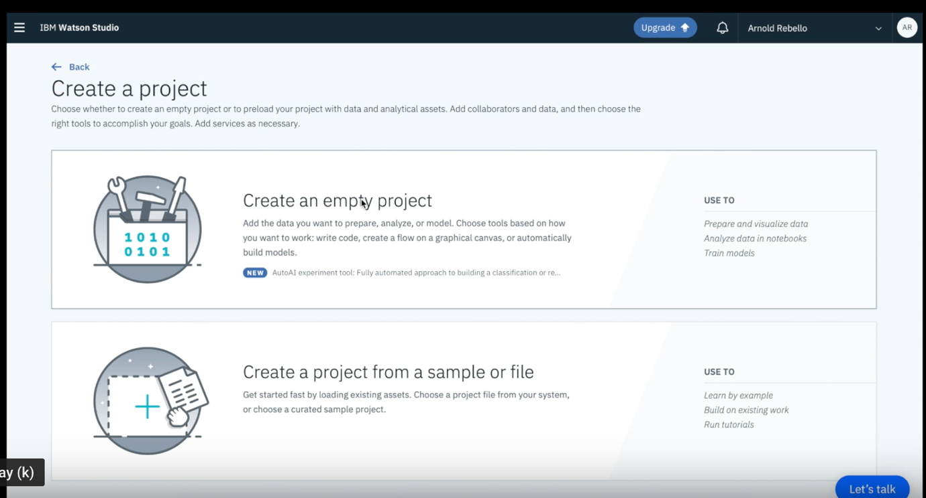

Give a name to your project and add description.

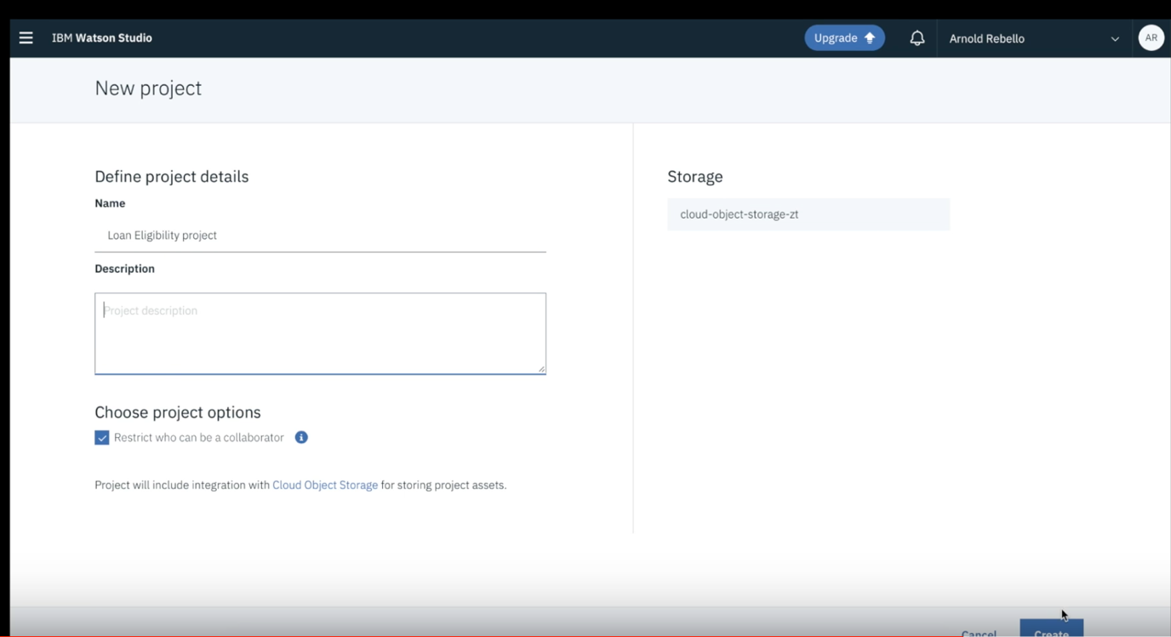

Select 0100 tab from the top right corner >> Catalog

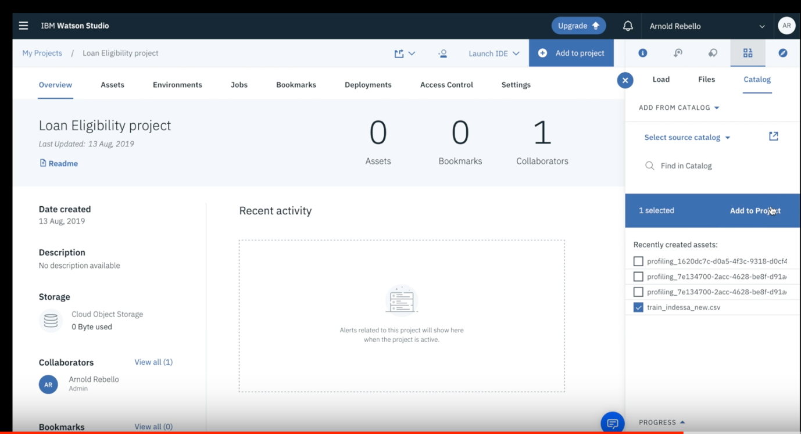

Confirm the Selection as shown below

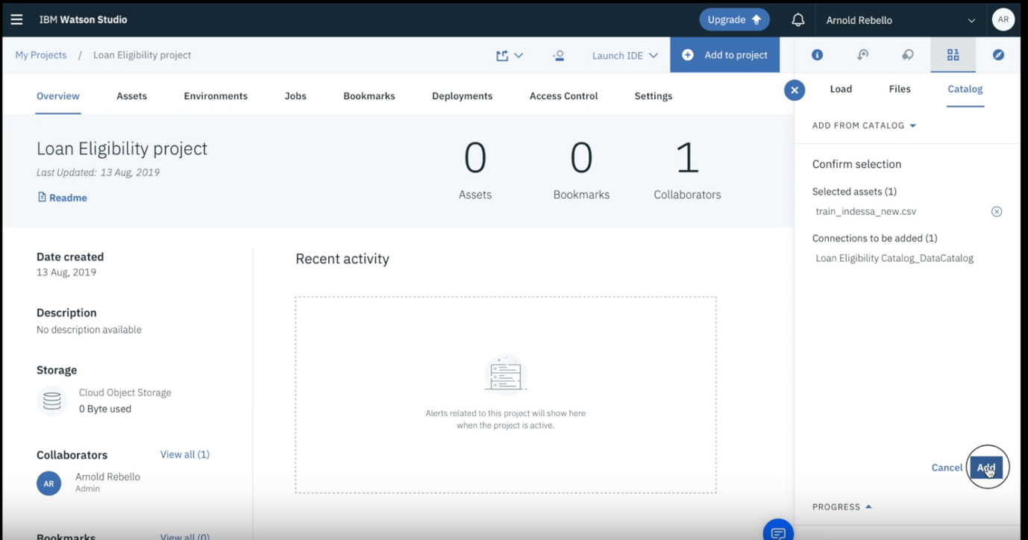

Select the recently created asset and click on “add”

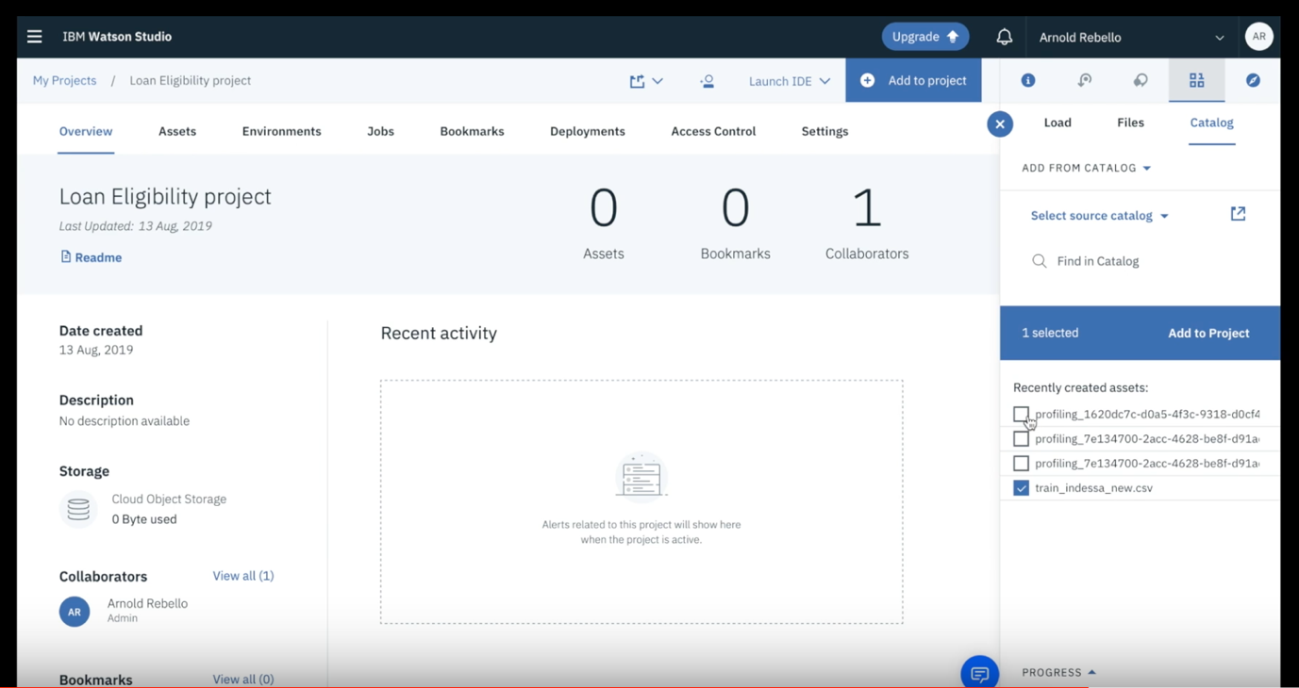

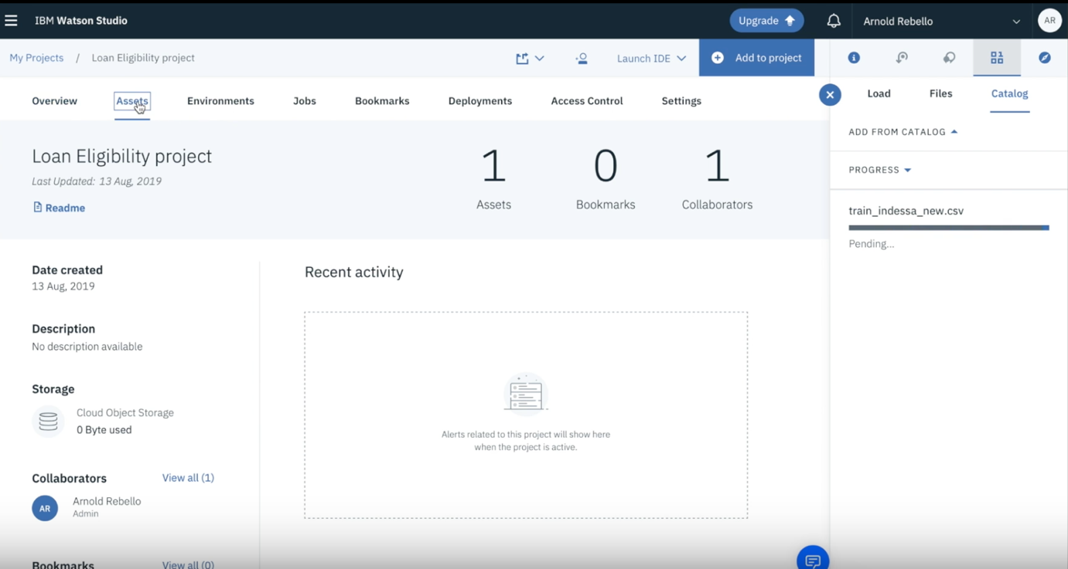

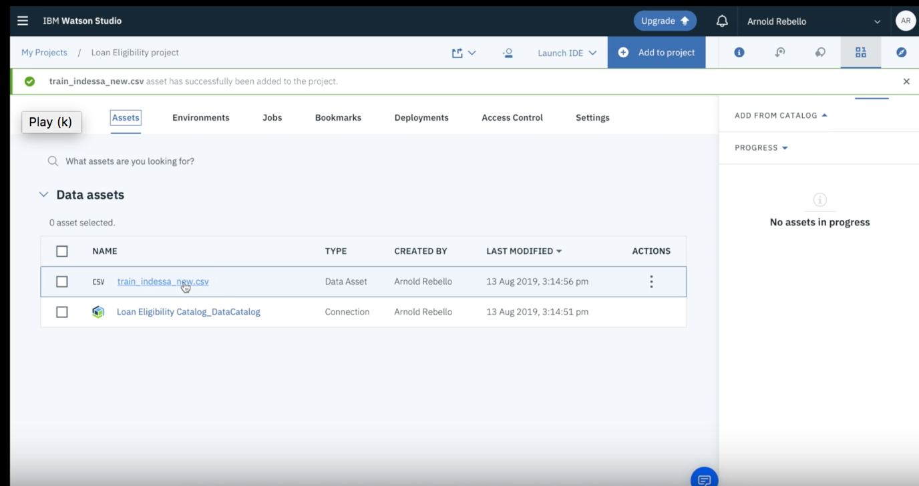

Click on the “Assets” and select the recently added asset.

Click on Profile and observe the changes as per the rule created earlier.

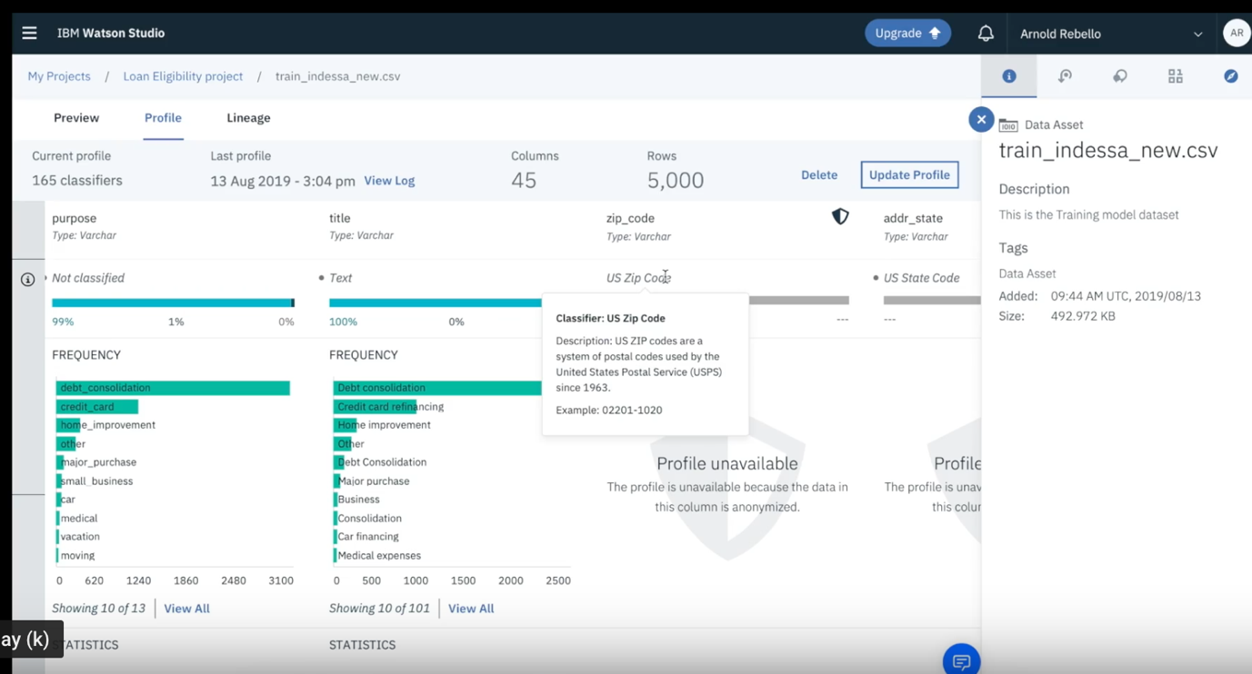

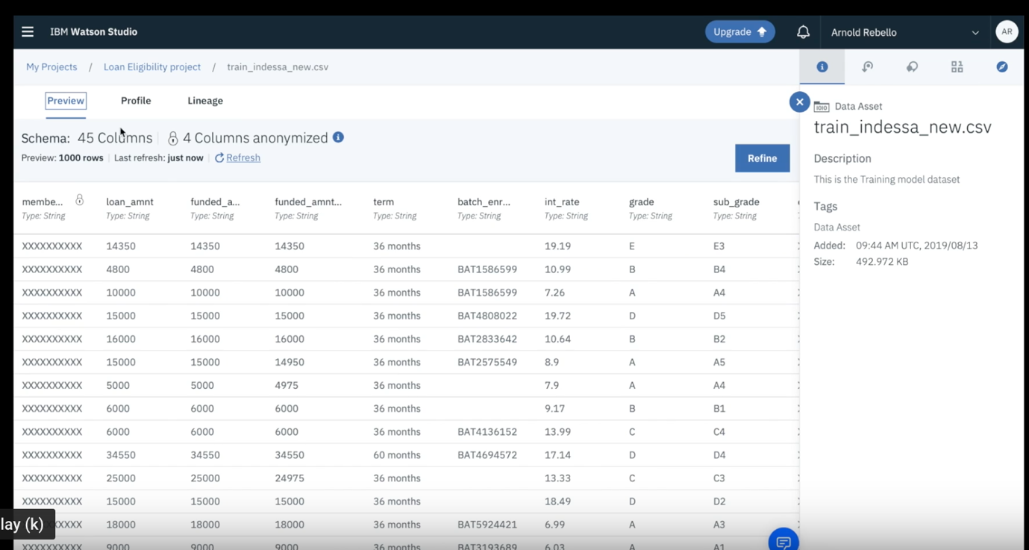

Hurray!!

Thank you for completing this lab. It should not take more than 20 minutes.